**Part 1**

**A1.** The website needs to be function properly to meet the needs of the audience and stakeholders. It needs to support all device sizes and follow accessibility guidelines. The website needs a search bar that works and a menu that is easy to navigate. There should be a "contact" page on it. To meet the expectations of the stakeholder, it has to include "new pet consultant" and "new pet care consultation”. Also, the website needs micro interactions like linking the pictures to the relevant pages, adding some working icons, a footer, and associating with pages in order to live up to audience expectations.

**A2.** A new page called "Birds" had to be created for bird owners. The website would offer useful advice for bird owners on topics like caring for birds and creating a healthier environment for them. Because bird owners frequently access the website using desktop computers, the website requires desktop adaptation.

**A3.** The website of Paradigm Pet Professionals has a logo, the name of the business, a simple navigation menu, and content. However, the website is missing some features and interactions to fulfill the audience and stakeholders' needs.

* Home, Cats, Dogs, and FAQs are all included on the menu. However, it is difficult to navigate, and it fails to meet the needs of audience and stakeholder. Visitors who select "Dog" continue to see information about dogs under "Cats" in the menu. Visitors who click "FAQs" are taken to the FAQs page in the menu on the "Home" page. The "Fetch" button is mostly ineffective. Additionally, nothing happens when you click the "Find something" search button. The audience will find it difficult to navigate and understand this menu, which confused the audience and is not what stakeholders are looking for. So, to fulfill the needs of the audience and the stakeholders, the “fetch” button should be removed. The menu and search bar need to be redeveloped.
* The website's goal is to provide resources for helping pets. However, this website's branding is inconsistent. The branding content is hidden in a paragraph and only visible on the "Home" page. The stakeholder does not expect this type of branding. The audience does not fully understand what this website is. It fails the needs of the audience and stakeholder. So, the part of content should be redeveloped.
* The images on the homepage are grouped together. The audience is only viewing images that aren't connected to the relevant sites. It doesn't meet the audience's needs. Instead, some of them should be removed and the images should be redeveloped.

• There are some mixed animal-related questions on the FAQs page. The audience might get lost in the questions, but they won't be able to find the answers. Additionally, there are no means of communicating with the audience to answer any concerns they may have. The stakeholder also expected that the audience would meet one-on-one with the pet specialists. It fails to meet the expectations of both the audience and the stakeholders. Therefore, I would remove the FAQs page and replace it with a new page where the audience can elaborate on their questions. I would also include a form to gather their contact information so that I could provide them with the consultant they need.

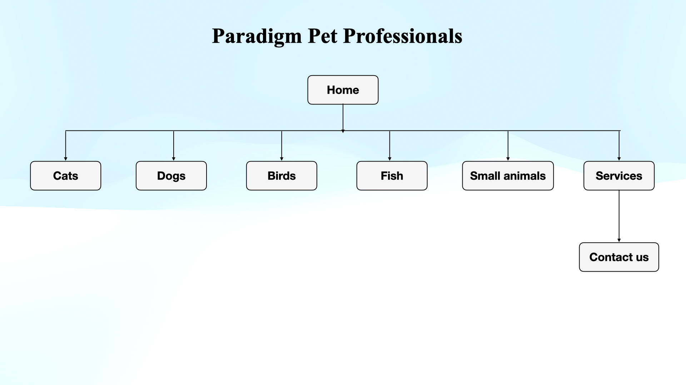**A4. Sitemap**

**A5.** The Paradigm Pet Professionals company will be introduced on the home page in order to meet the branding needs of the stakeholders. When users search for it, "new pet consultant" or "new pet care consultant" will appear on the first page. With sites designated to cats, dogs, birds, fish, and small animals, the website will be responsive to the demands of pet owners. They will go to service to receive contact information or add their basic contact information, including them and their pets, if they have any additional queries or like to speak with a pet expert.

**A6.** The primary navigational elements are including Home, Cats, Dogs, Birds, Fish, and Small animal. The secondary navigational elements have Contact Us and search bar.

**A6a.**The primary navigational elements and the secondary elements will satisfy the needs of the audience. Pet owners have easy access to information on the necessities for a variety of pets. The search bar and contact information for the pet experts make it easier for the audience to connect. Because they are easy to use and comprehend, the navigational components also meet the needs of stakeholders. Moreover, the site aim will be achieved with more visitors and consultants.

**B. Wireframe:**

